**(DSA LAB REPORT 01)**

**NAME:Amina Ijaz 055**

**ET (B)**

**Code 1**

#include <iostream>

using namespace std;

int main() {

int marks[10];

int first = -1, second = -1;

cout << "Enter 10 marks: ";

for (int i = 0; i < 10; i++) {

cin >> marks[i];

}

for (int i = 0; i < 10; i++) {

if (marks[i] > first) {

second = first;

first = marks[i];

}

else if (marks[i] > second && marks[i] != first) {

second = marks[i];

}

}

cout << "1st highest mark = " << first << endl;

cout << "2nd highest mark = " << second << endl;

return 0;

}

**OUTPUT:**

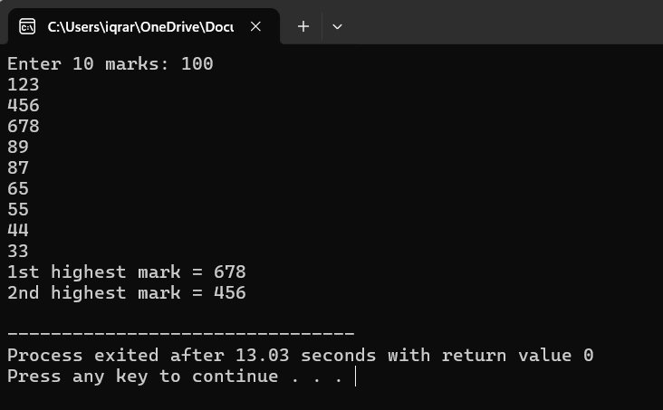

PROGRAM 2

#include <iostream>

using namespace std;

int main() {

int n;

cout << "Enter size of array: ";

cin >> n;

int arr[n];

cout << "Enter " << n << " elements in ascending order:\n";

for (int i = 0; i < n; i++) {

cin >> arr[i];

}

int key;

cout << "Enter number to search: ";

cin >> key;

int low = 0, high = n - 1;

bool found = false;

while (low <= high) {

int mid = (low + high) / 2;

if (arr[mid] == key) {

found = true;

break;

}

else if (arr[mid] < key) {

low = mid + 1;

}

else {

high = mid - 1;

}

}

if (found)

cout << key << " found in array.\n";

else

cout << key << " not found in array.\n";

return 0;

}

**Output:**

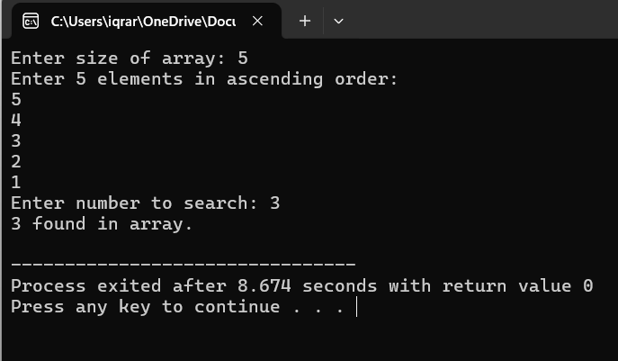

(PROGRAM 03)

#include <iostream>

using namespace std;

int main() {

int marks[6];

int sum = 0;

cout << "Enter marks of 6 subjects: ";

for (int i = 0; i < 6; i++) {

cin >> marks[i];

sum += marks[i];

}

float average = sum / 6.0;

cout << "Average Marks: " << average << endl;

cout << "Grade: ";

if (average > 90)

cout << "A+\n";

else if (average > 80)

cout << "A\n";

else if (average > 70)

cout << "B\n";

else if (average > 60)

cout << "C\n";

else if (average > 50)

cout << "D\n";

else

cout << "F\n";

return 0;

}

**OUTPUT:**

